Investment and finance exam

Exercise 1
$$\overline{r}=\left(\begin{aligned}0.1 \\ 0.08 \\ 0.15\end{aligned}\right)$$
$$Σ=\left(\begin{matrix}0.18 & 0.02 & 0.08 \\ 0.02 & 0.1 & 0.1 \\ 0.08 & 0.1 & 0.25\end{matrix}\right)$$
a)
$$w=\left(\begin{aligned}0.36 \\ 0.74 \\ -0.1\end{aligned}\right)$$
We calculate using standard formulas
$${\overline{r}}_{w}={\overline{r}}^{T}·w=transpose\left(\left(\begin{aligned}0.1 \\ 0.08 \\ 0.15\end{aligned}\right)\right)\left(\begin{aligned}0.36 \\ 0.74 \\ -0.1\end{aligned}\right) ≈0,0802$$
$$σ_{w}^{2}=w^{T}·Σ·w=transpose\left(\left(\begin{aligned}0.36 \\ 0.74 \\ -0.1\end{aligned}\right) \right)\left(\begin{matrix}0.18 & 0.02 & 0.08 \\ 0.02 & 0.1 & 0.1 \\ 0.08 & 0.1 & 0.25\end{matrix}\right)\left(\begin{aligned}0.36 \\ 0.74 \\ -0.1\end{aligned}\right)=0,070684$$
b)
we are in the markowitz framework so we simply use the formula that we know gives exactly the minimum variance given wanted return in this world
$$w^{⋆}=\frac{a·{\overline{r}}_{p}-b}{d}Σ^{-1}\overline{r}+\frac{c-{\overline{r}}_{p}b}{d}Σ^{-1}I$$
With
$$a=I^{T}Σ^{-1}I$$
$$b=I^{T}Σ^{-1}\overline{r}$$
$$c={\overline{r}}^{T}Σ\overline{r}$$
$$d=ac-b^{2}$$
We use our r document from the coding bootcamp
Which gives us
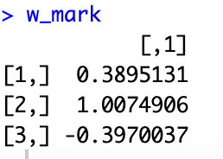
Ill call whis portfolio B
$$w_{B}=\left(\begin{aligned}0.3895 \\ 1.0075 \\ -0.3970\end{aligned}\right)$$
This asset has a vaiance
$$transpose\left(\left(\begin{aligned}0.3895 \\ 1.0075 \\ -0.3970\end{aligned}\right)\right)\left(\begin{matrix}0.18 & 0.02 & 0.08 \\ 0.02 & 0.1 & 0.1 \\ 0.08 & 0.1 & 0.25\end{matrix}\right)\left(\begin{aligned}0.3895 \\ 1.0075 \\ -0.3970\end{aligned}\right)≈0,079176$$
And is thus a “better” asset than the portfolio described in (a)
Since it has the same return(roughly) and lower variance

c) again we have a formula for the weights of this portolio
$$w_{tan}=\frac{Σ^{-1}{\overline{r}}_{e}}{I^{T}Σ^{-1}{\overline{r}}_{e}}$$
$${\overline{r}}_{e}=\overline{r}-r_{f}·I=\left(\begin{aligned}0.1 \\ 0.08 \\ 0.15\end{aligned}\right)-0.02=\left(\begin{matrix}0,08 \\ 0,06 \\ 0,13\end{matrix}\right)$$

$$w_{tan}=\frac{{\left(\begin{matrix}0.18 & 0.02 & 0.08 \\ 0.02 & 0.1 & 0.1 \\ 0.08 & 0.1 & 0.25\end{matrix}\right)}^{-1}\left(\begin{matrix}0,08 \\ 0,06 \\ 0,13\end{matrix}\right)}{transpose\left(\left(\begin{aligned}1 \\ 1 \\ 1\end{aligned}\right)\right){\left(\begin{matrix}0.18 & 0.02 & 0.08 \\ 0.02 & 0.1 & 0.1 \\ 0.08 & 0.1 & 0.25\end{matrix}\right)}^{-1}\left(\begin{matrix}0,08 \\ 0,06 \\ 0,13\end{matrix}\right)}≈\left(\begin{matrix}0,3246753 \\ 0,2294372 \\ 0,4458874\end{matrix}\right)$$
And we use standard formulas to find mean and variance
$${\overline{r}}_{tan}=transpose\left(\left(\begin{aligned}0.1 \\ 0.08 \\ 0.15\end{aligned}\right)\right)\left(\begin{matrix}0,3246753 \\ 0,2294372 \\ 0,4458874\end{matrix}\right)≈0,1177056$$
$$σ_{tan}^{2}=transpose\left(\left(\begin{matrix}0,3246753 \\ 0,2294372 \\ 0,4458874\end{matrix}\right)\right)\left(\begin{matrix}0.18 & 0.02 & 0.08 \\ 0.02 & 0.1 & 0.1 \\ 0.08 & 0.1 & 0.25\end{matrix}\right)\left(\begin{matrix}0,3246753 \\ 0,2294372 \\ 0,4458874\end{matrix}\right)≈0,1205459$$
d) I would recommend an efficient asset
from the one fund theorem we know that any efficient asset when there is a risk free asset must be a combination of the tangency portfolio and the risk free asset
thus we want to find the weights in the tangency portfoilio and the risk free portfolio such that

$$0.06=α·{\overline{r}}_{tan}+\left(1-α\right)r_{f}$$
$$0.06=α·0,1177056+\left(1-α\right)0.02$$
$⇕$ Ligningen løses for α vha. WordMat.
$$α=0,4093931$$
$$1-0,4093931=0,5906069$$

Thus we must have $40.94\%$ in the tangency portfolio and $59.06\%$ in the risk free asset
Rhis gives us a total portfolio with the 4. Asset being the risk free one
$$w_{effecient}=0,4093931\left(\begin{aligned}0,3246753 \\ 0,2294372 \\ 0,4458874 \\ 0\end{aligned}\right)+0,5906069·\left(\begin{aligned}0 \\ 0 \\ 0 \\ 1\end{aligned}\right)≈\left(\begin{matrix}0,1329198 \\ 0,09393 \\ 0,1825432 \\ 0,5906069\end{matrix}\right)$$
e) to show that it is on the SML we must first find its beta
when CAPM is satisfied then
$$w_{tan}=w_{m}$$
vaiance and return also
we can calculate all 3 assets beta at once
$$β=\frac{1}{σ_{m}^{2}}·Σ·w_{m}$$
$$=\frac{1}{0,1205459}·\left(\begin{matrix}0.18 & 0.02 & 0.08 \\ 0.02 & 0.1 & 0.1 \\ 0.08 & 0.1 & 0.25\end{matrix}\right)·\left(\begin{matrix}0,3246753 \\ 0,2294372 \\ 0,4458874\end{matrix}\right)≈\left(\begin{matrix}0,818786 \\ 0,6140895 \\ 1,3305272\end{matrix}\right)$$
$$β_{1}=0.818786$$
$$β_{2}=0.6140895$$
$$β_{3}=1.3305272$$
The SML:

$$\overline{r_{i}}=r_{f}+β_{i}\left({\overline{r}}_{m}-r_{f}\right)$$
For asset 1
$$r_{f}+β_{1}\left({\overline{r}}_{m}-r_{f}\right)=0.02+0.818786\left(0,1177056-0.02\right)=0,0999999774016≈0.1={\overline{r}}_{1}$$
Im thinking the difference is simply inaccuracy of the calculations
Thus the asset is on the SML

f)
we have that in capm
$$σ_{i}^{2}=β_{i}·σ_{m}^{2}+σ_{ϵ_{i}}^{2}⇔σ_{i}^{2}-β_{i}·σ_{m}^{2}=σ_{ϵ_{i}}^{2}$$
Where $σ_{ϵ_{i}}^{2}$ is the unsystematic risk
We simply calculate these
Asset 1
$$0.18-{0.818786}^{2}·0,1205459≈0,0991848$$
Asset 2
$$0.1-{0.6140895}^{2}·0,1205459≈0,0545414$$
Asset 3
$$0.25-{1.3305272}^{2}·0,1205459≈0,0365973$$
Thus asset 1 has the highest unsystematic risk

Exercise 2
a)
We write up a bond market matrix
$$B=\left(\begin{matrix}103 & 0 & 0 \\ 4 & 104 & 0 \\ 6 & 6 & 106\end{matrix}\right)$$
When the calculate discountfactors using the spotrates
$$d_{1}=\frac{1}{1+0.04}≈0,9615385$$
$$d_{2}=\frac{1}{{\left(1+0.05\right)}^{2}}≈0,9070295$$
$$d_{3}=\frac{1}{{\left(1+0.07\right)}^{3}}≈0,8162979$$
As a vector
$$d=\left(\begin{aligned}0,9615385 \\ 0,9070295 \\ 0,8162979\end{aligned}\right)$$
Then we can simply get a pricevector
$$B·d=P$$
$$\left(\begin{matrix}103 & 0 & 0 \\ 4 & 104 & 0 \\ 6 & 6 & 106\end{matrix}\right)\left(\begin{aligned}0,9615385 \\ 0,9070295 \\ 0,8162979\end{aligned}\right)≈\left(\begin{matrix}99,0384655 \\ 98,177222 \\ 97,7389854\end{matrix}\right)$$
With the asset being in the order
A,B,C
b) yes since B is ivertible especially there are 3 linearly independent assest being traded and thus any cashflow wanted can be created as a linear combination of the 3 cupon bonds

short: since $Rank\left(B\right)=3=T$ then the market is complete
c)
we calculate the arbitragefree price of the bond in this market
$$P=B^{'}·d$$
$$B^{'}=\left(\begin{matrix}0 & 100 & 0\end{matrix}\right)$$
$$P=\left(\begin{matrix}0 & 100 & 0\end{matrix}\right)·\left(\begin{aligned}0,9615385 \\ 0,9070295 \\ 0,8162979\end{aligned}\right)=90,70295$$
Thus the price of the ZCB is to low and there is arbitrage in the market
We will show this further in the next part
d) we replicate the cashflow in the market then “buy low sell high” selling the expensive asset and buying the cheap one

we recreate the cashflow in the market of cupon bonds
$$\left(\begin{matrix}0 & 100 & 0\end{matrix}\right){\left(\begin{matrix}103 & 0 & 0 \\ 4 & 104 & 0 \\ 6 & 6 & 106\end{matrix}\right)}^{-1}≈\left(\begin{matrix}-0,0373413 & 0,9615385 & 0\end{matrix}\right)=θ$$
This portfolio pays out exactly 100 at time 2 just like the ZCB
An it costs
$$\left(\begin{matrix}-0,0373413 & 0,9615385 & 0\end{matrix}\right)\left(\begin{matrix}99,0384655 \\ 98,177222 \\ 97,7389854\end{matrix}\right)≈90,7029537$$
To make a profit we simply sell the replication and buy the ZCB making the total portfoilo
With the weights being in the order A,B,C,ZCB

$$θ_{total}=-\left(\begin{matrix}-0,0373413 & 0,9615385 & 0 & 0\end{matrix}\right)+\left(\begin{matrix}0 & 0 & 0 & 1\end{matrix}\right)=\left(\begin{matrix}0,0373413 & -0,9615385 & 0 & 1\end{matrix}\right)$$
We update our market matrix to make sure we have 0 cashflows

$$B=\left(\begin{matrix}103 & 0 & 0 \\ 4 & 104 & 0 \\ 6 & 6 & 106 \\ 0 & 100 & 0\end{matrix}\right)$$
$$B_{θ}=\left(\begin{matrix}0,0373413 & -0,9615385 & 0 & 1\end{matrix}\right)\left(\begin{matrix}103 & 0 & 0 \\ 4 & 104 & 0 \\ 6 & 6 & 106 \\ 0 & 100 & 0\end{matrix}\right)=\left(\begin{matrix}-1·{10}^{-7} & -4·{10}^{-6} & 0\end{matrix}\right)$$
Again I believe the small difference is due to computation error
For the price
$$\left(\begin{matrix}0,0373413 & -0,9615385 & 0 & 1\end{matrix}\right)\left(\begin{aligned}99,0384655 \\ 98,177222 \\ 97,7389854 \\ 90\end{aligned}\right)≈-0,7029537$$
Since $B_{1},B_{2},B_{3}≥0,P<0$ there is arbitrage
To take advantage of this we simply go long a huge amount of the portfolio described making
$0.7$ for every one
e)
plugging into the formula
$$s_{t}=0.05-0.01·\frac{1-e^{-t}}{t}+0.04·\left(\frac{1-e^{-t}}{t}-e^{-t}\right)$$
$$s_{\frac{1}{2}}=0.05-0.01·\frac{1-e^{-\frac{1}{2}}}{\frac{1}{2}}+0.04·\left(\frac{1-e^{-\frac{1}{2}}}{\frac{1}{2}}-e^{-\frac{1}{2}}\right) ≈0,0493469$$
$$s_{\frac{3}{2}}=0.05-0.01·\frac{1-e^{-1.5}}{1.5}+0.04·\left(\frac{1-e^{-1.5}}{1.5}-e^{-1.5}\right)≈0,0566122$$
$$s_{\frac{5}{2}}=0.05-0.01·\frac{1-e^{-2.5}}{2.5}+0.04·\left(\frac{1-e^{-2.5}}{2.5}-e^{-2.5}\right)≈0,0577316$$
f)
flat price
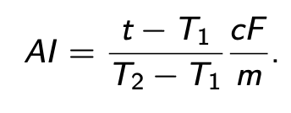
Since we are exactly one year from the next payment
Then we are at $t=T_{1}$
Thus
Since we are exactly one year before delivery there is no accured interst and the flat price is simply the price
$$AI=0$$
And
$$P_{flat}=PV\left(future cashflows\right)=P_{C}=97,7389854$$

exercise 3
we note a couple of things in the beginning
first the model has constant up/downs
$$u=1.1$$
$$d=0.9$$
A continous compounded risk free rate and thus a discountfactor
$$r=0.02$$
$$d_{0,t}=e^{-r·t}$$
And that the derivative described is a combination of a european put and call that can have different strikes that I will note
$$C^{X_{1}}-P^{X_{2}}$$

a)
we simply have a formula
$$q=\frac{e^{r·Δt}-d}{u-d}=\frac{e^{0.02}-0.9}{1.1-0.9}≈0,6010067$$
$$1-q=1-0,6010067=0,3989933$$
We know that a property of the risk neutral measure and pricing in general is
$$S_{0}=E^{Q}\left[S_{T}\right]·d_{0,T}⇒E^{Q}\left[S_{T}\right]=\frac{S_{0}}{d_{0,T}}$$
I will still do the calculation of course
Im thinking we are to calculate
$$E^{Q}\left[S_{1}\right],E^{Q}\left[S_{2}\right], E^{Q}[S_{3}]$$

$$E^{Q}\left[S_{1}\right]=q·S_{u}+\left(1-q\right)·S_{d}=0,6010067·110+0,3989933·90=102,020134$$
$$E^{Q}\left[r_{1}\right]=\frac{E^{Q}\left[S_{1}\right]}{S_{0}}-1=\frac{102,020134}{100}-1≈0,0202013=e^{0.02}-1$$
$$E^{Q}\left[S_{2}\right]=q^{2}·S_{uu}+2·\left(q·\left(1-q\right)\right)·S_{ud}+{\left(1-q\right)}^{2}·s_{dd}={0,6010067}^{2}·121+2·0,6010067·0,3989933·99+{0,3989933}^{2}·81≈104,0810774$$
$$E^{Q}\left[r_{2}\right]=\frac{104,0810774}{100}-1≈0,0408108=e^{0.04}-1$$

$$E^{Q}\left[S_{3}\right]=q^{3}·s_{uuu}+3·q^{2}·\left(1-q\right)·s_{uud}+3·q·{\left(1-q\right)}^{2}·S_{udd}+{\left(1-q\right)}^{3}·s_{ddd}$$
$$={0,6010067}^{3}·133.1+3·{0,6010067}^{2}·0,3989933·108.9+3·{0,6010067}^{1}·{0,3989933}^{2}·89.1+{0,3989933}^{3}·72.9≈106,1836546$$
$$E^{Q}\left[r_{3}\right]=\frac{106,1836546}{100}-1≈0,0618365=e^{0.06}-1$$

b)
this is simply a forward contract
by realising our position is a combination of a european put and a call in this situation with the same strike we can use the put call parity since we are long the call and short the put with same strike and expiration which says that the price of this must be the price of a forward with strike K
$$C-P=S_{0}-K·e^{-rT}$$
$$=100-95·e^{-0.02·3}≈10,5323693$$
The payout can be written
$$\max\left\{0,S_{3}-K\right\}-\max{\{K-S_{3},0\}}=S_{3}-K$$
Which is the payoff of a forward contract
c) the derivative is still just a combination of a call and a put thus we price them seperately and calulate add them together
first the call
$$C^{105}$$
We note that it only pays out in the “uuu” state and “uud” states
And price using the expected value under Q and discounting it
$$C_{0}^{105}=e^{-0.02·3}·\left(q^{3}·\left(133.1-105\right)+3·q^{2}·\left(1-q\right)·\left(108.9-105\right)\right)$$
$$=e^{-0.02·3}·\left({0,6010067}^{3}·\left(133.1-105\right)+3·{0,6010067}^{2}·\left(1-0,6010067\right)·\left(108.9-105\right)\right)≈7,3329615$$
Then the put
Which again only pays out in the “ddd” and “udd” states and do the exact same as with the call
$$P_{0}^{95}=e^{-0.02·3}·\left(q·{\left(1-q\right)}^{2}·\left(95-89.1\right)·3+{\left(1-q\right)}^{3}·\left(95-72.9\right)\right)$$
$$=e^{-0.02·3}·\left(0,6010067·{\left(1-0,6010067\right)}^{2}·\left(95-89.1\right)·3+{\left(1-0,6010067\right)}^{3}·\left(95-72.9\right)\right)≈2,9168729$$
Thus the value of the derivative
$$P_{0}^{d}=C_{0}^{105}-P_{0}^{95}=7,3329615-2,9168729=4,4160886$$
d) again we simply calculate the expected value under Q and discount
we note that it pays out 10 in the “uuu” and “uud” states
$$P_{0}^{binary}=e^{-0.02·3}·\left(10·\left(q^{3}+3\left(q^{2}·\left(1-q\right)\right)\right)\right)$$
$$=e^{-0.02·3}·\left(10·\left({0,6010067}^{3}+3\left({0,6010067}^{2}·\left(1-0,6010067\right)\right)\right)\right)≈6,1162807$$
The binary is more expensive than the asset in (c) but has no downside risk it misses out on the bigger upside in the “uuu” case but earns more in the “uud” state which is more likely

Trying to relate the asset to the asset from (b) we note that it is cheaper ang again has no downside risk but the forward has bigger upsides to in both states

Im thinking this asset might be good as an alternative for a call with lover variance of return but also lower upside potential (no probability of hitting it out of the park)

e) at all times we simply solve the system of equations with “0” being the state we are In and “u”,”d” being going up and down from there
$$P_{u}=S_{u}·Δ+e^{r·Δt}·B$$
$$P_{d}=S_{d}·Δ+e^{r·Δt}·B$$
Where $Δ$ is the amount of the asset in we need to hold
And $B$ is the amount we need to invest in the risk free asset

“uu”
$$10=133.1·Δ+e^{0.02}·B$$
$$10=108.9·Δ+e^{0.02}·B$$
$⇕$
$$Δ=0 ∧ B=9,8019867$$
Makes sence since we have a guarentied return of 10

“ud”
$$10=108.9·Δ+e^{0.02}·B$$
$$0=89.1·Δ+e^{0.02}·B$$
$⇕$
$$Δ=0,5050505 ∧ B=-44,1089403$$

“dd”

$$0=89.1·Δ+e^{0.02}·B$$
$$0=72.9·Δ+e^{0.02}·B$$
$⇕$
$$Δ=0 ∧ B=0$$
Which again makes sence since we never get a payout
f)
again we simply find the expected value under Q and discount it
we note that it pays out if $S_{T}≥K$
thus we can write the payoff
$$=10·I_{\left\{S_{T}≥K\right\}}$$
Since we are in a BSM world we know from slides that
$$d\log\left(S_{T}\right)=\left(μ-\frac{1}{2}σ^{2}\right)dt+σ dW_{t}$$
And that under the risk neutral measure using girsanows theorem
$$d\log\left(S_{T}\right)=\left(r-\frac{1}{2}σ^{2}\right)dt+σ dW_{t}^{Q}$$
This also means
$$\log\left(S_{T}\right)=\log\left(S_{t}\right)+\int_{t}^{T}{\left(r-\frac{1}{2}σ^{2}\right)ds}+\int_{t}^{T}{σdW_{s}^{Q}}$$
$$=\log\left(S_{t}\right)+\left(T-t\right)·\left(r-\frac{1}{2}σ^{2}\right)+σ·W_{T-t}$$
Where
$$W_{T-t}\sim N\left(0,T-t\right)$$
Thus $S_{T}=S_{t}·e^{\left(r-\frac{σ^{2}}{2}\right)·\left(T-t\right)+σ·W_{T-t}}$
We now calculate
The expectation under Q
$$E^{Q}\left[10·I_{\left\{S_{T}≥K\right\}}\right]$$
We note that
$$E^{Q}\left[10·I_{\left\{S_{T}≥K\right\}}\right]=10·P^{Q}(S_{T}≥K)$$

$$S_{T}≥K⇔S_{t}·e^{\left(r-\frac{σ^{2}}{2}\right)·\left(T-t\right)+σ·W_{T-t}}≥K$$
$$\left(r-\frac{σ^{2}}{2}\right)·\left(T-t\right)+σ·W_{T-t}≥\log\left(\frac{K}{S_{t}}\right)$$
$$σ·W_{T-t}≥\log\left(\frac{K}{S_{t}}\right)-\left(r-\frac{σ^{2}}{2}\right)·\left(T-t\right)$$
We introduce a variable
$$X=\frac{W_{T-t}}{\sqrt{T-t}}\sim N\left(0,1\right)$$

$$σ·W_{T-t}=σ·\sqrt{T-t}·X≥\log\left(\frac{K}{S_{t}}\right)-\left(r-\frac{σ^{2}}{2}\right)·\left(T-t\right)$$
$$⇔X≥\frac{\log\left(\frac{K}{S_{t}}\right)-\left(r-\frac{σ^{2}}{2}\right)·\left(T-t\right)}{σ·\sqrt{T-t}}=-d_{2}$$
We note that the expression above is simply $-d_{2}$ as given in the exercise
$$P^{Q}\left(S_{t}≥K\right)=P^{Q}\left(X≥-d_{2}\right)=1-P^{Q}\left(X≤-d_{2}\right)$$
Since X is standard normal
$$=1-N(-d_{2})$$
But again since its standard normal
$$=N\left(d_{2}\right)$$
Thus
$$E^{Q}\left[10·I_{\left\{S_{T}≥K\right\}}\right]=10·N\left(d_{2}\right)$$
And we simply need to discount it
$$P^{binary}=e^{-r(T-t)}·E^{Q}\left[10·I_{\left\{S_{T}≥K\right\}}\right]=e^{-r(T-t)}·10·N\left(d_{2}\right)$$
Just as given in the exerise thus her claim must be right

Exercise 4
a)
We use general pricing principels
$$P=E^{Q}\left[d_{1}·X\right]$$
In the first period the interestrate is certain and that it only pays out 100 in the “down state”
$$P=\frac{1}{1.05}·\left(1-q\right)·100=\frac{1}{1.05}·\left(1-0.5\right)·100≈47,6190476$$
b)
we calculate the stateprices on a tree in excel and add them up to get the ZCB prices
using the formulas
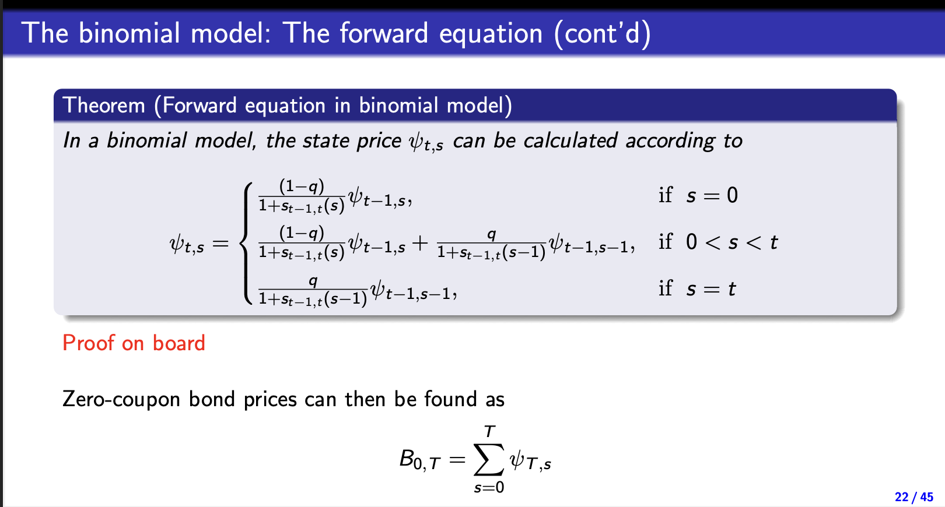
This gives us the the stateprice tree
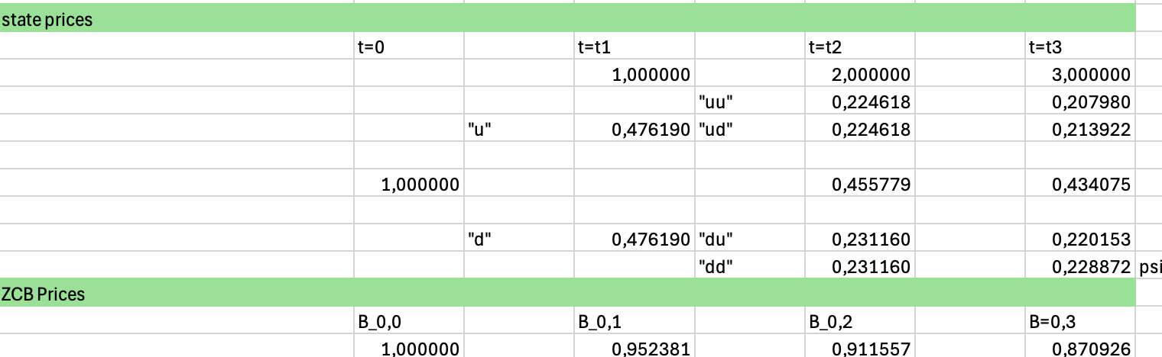
With tme middel row after the first denoting where the 2 paths meet adding them together
The sum of these are exacly our ZCB prices with principal 1

$$B_{0,1}=100·0.952381=95,2381$$
$$B_{0,2}=100·0.911557=91,1557$$
$$B_{0,3}=0.870926·100=87,0926$$
The yields on ZCB are exactly the spotrates
$$λ_{0,1}$$
$$\frac{100}{1+λ}=95,2381$$
$⇕$
$$λ_{0,1}=0,0499999=5\%$$

$$λ_{0,2}:$$
$$\frac{100}{{\left(1+λ\right)}^{2}}=91,1557$$
$⇕$
$$λ=0,0473892$$
This one is slightly off im hoping that there is a missing didget since the 2 others are spot on

$$λ_{0,3}:$$
$$\frac{100}{{\left(1+λ\right)}^{3}}=87,0926$$
$⇕$ Ligningen løses for λ vha. WordMat.
$$λ=0,0471436$$
c) the price of the callable bond
$$P_{callable}=P_{noncallable}-P_{option}$$
We will simply price the option
this person will call the bond if the the value of the bond is higher than 90
thus if he can make a profit at time 1 he will buy it back for 90 and im assuming sell it again simply pocketing the difference
we calculate the ZCB prices in the “up state” this we again have done on a tree where we calculate the ZCB prices backwards with the formula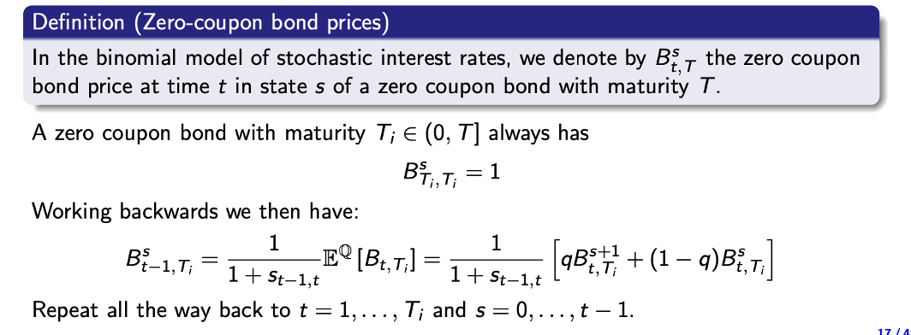
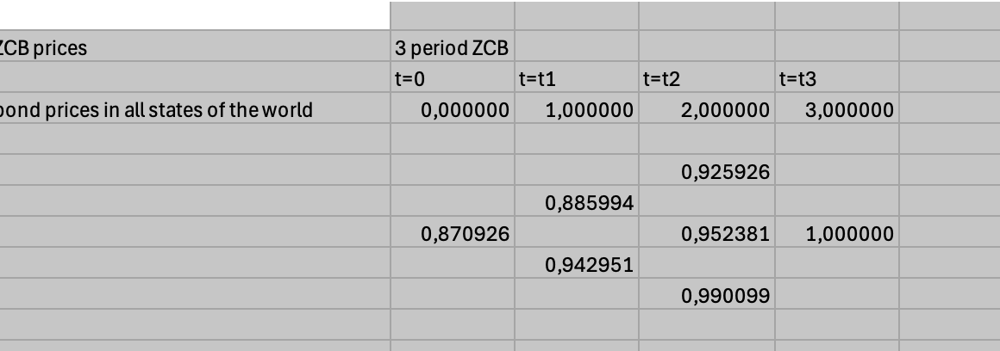
The value of the ZCB with expiration at time 3 can then easily be calculated
$$B_{1,3}^{u}=0.885884·100≈88,5884$$
$$B_{1,3}^{d}=100·0.942951=94,2951$$
We then realise that he exercises in the “down” state
Earning
$$94.2951-90≈4,2951$$
We can price this option with state prices
$$ψ_{1,0}=\frac{0.5}{1.05}≈0,4761905$$
$$4.2951·0,4761905≈2,0452858$$
Then we price the callable bond
$$P_{callable}=87,0926-2,0452858=85,0473142$$
d)
we need to have enough of the claim that we get $4,2951$ in state “d”
thus
$$\frac{4,2951}{100}≈0,042951$$
This costs
$$47,6190476·0,042951≈2,0452857$$
As well as our normal bond
$$B_{03}=87,0926$$
By selling the bond and buying the derivative we reach the position of the callable bond
The price we reach is then
$$P_{portfolio}=87,0926-2,0452857≈85,0473143$$
Which is (with a very small error) the same as the price of the callable bond

e)

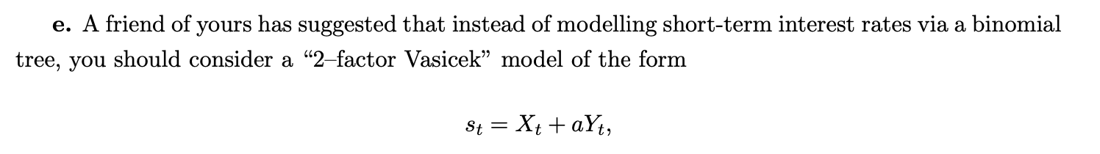
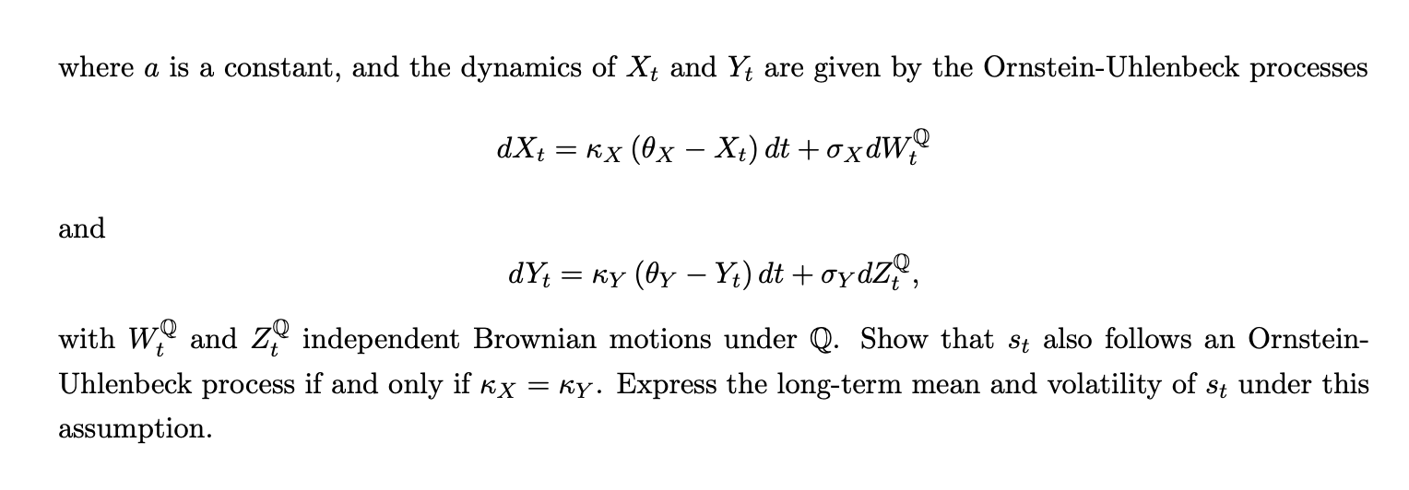
We write both out
$$X_{T}=X_{t}+\int_{t}^{T}{κ_{X}\left(θ_{X}-X_{t}\right)dt}+σ_{X}·W_{T-t}^{Q}⇒X_{T}-X_{t}=\int_{t}^{T}{κ_{X}\left(θ_{X}-X_{t}\right)dt}+σ_{X}·W_{T-t}^{Q}$$
$$Y_{T}=Y_{t}+\int_{t}^{T}{κ_{Y}\left(θ_{Y}-Y_{t}\right)dt}+σ_{Y}·Z_{T-t}^{Q}⇒Y_{T}-Y_{t}=\int_{t}^{T}{κ_{Y}\left(θ_{Y}-Y_{t}\right)dt}+σ_{Y}·Z_{T-t}^{Q}$$
$$s_{T}-s_{t}=X_{T}-X_{t}+α·\left(Y_{T}-Y_{t}\right)$$
$$=\int_{t}^{T}{κ_{X}\left(θ_{X}-X_{t}\right)dt}+σ_{X}·W_{T-t}^{Q}+α·\left(\int_{t}^{T}{κ_{Y}\left(θ_{Y}-Y_{t}\right)dt}+σ_{Y}·Z_{T-t}^{Q}\right)$$
$$=\int_{t}^{T}{κ_{X}\left(θ_{X}-X_{t}\right)+ακ_{Y}\left(θ_{Y}-Y_{t}\right)dt}+σ_{X}·W_{T-t}^{Q}+α·σ_{Y}·Z_{T-t}^{Q}$$
If and only if $κ_{X}=κ_{Y}$ then we call it $κ_{s}$
$$=\int_{t}^{T}{κ_{X}\left(θ_{X}-X_{t}\right)+ακ_{Y}\left(θ_{Y}-Y_{t}\right)dt}+σ_{X}·W_{T-t}^{Q}+α·σ_{Y}·Z_{T-t}^{Q}$$
$$=\int_{t}^{T}{κ_{s}(θ_{X}+αθ_{Y}-X_{t}-αY_{t})dt}+σ_{X}·W_{T-t}^{Q}+α·σ_{Y}·Z_{T-t}^{Q}$$
Since W and Z are incependant normal the sum is normal
$$E\left[σ_{X}W+σ_{Y}αZ\right]=0$$
$$V\left[σ_{X}W+σ_{Y}αZ\right]=σ_{X}^{2}·\left(T-t\right)+α^{2}·σ^{2}·(T-t)$$
Thus
$$σ_{X}W+σ_{Y}αZ\sim N(0,(σ_{X}^{2}+α^{2}·σ_{Y}^{2})(T-t))$$
By introducing a new normal variable
$$G_{T-t}\sim N(0,\left(T-t\right))$$
And setting
$$σ_{S}=\sqrt{σ_{X}^{2}+α^{2}·σ_{Y}^{2}}$$
We can write
$$=\int_{t}^{T}{κ_{s}(θ_{X}+αθ_{Y}-X_{t}-αY_{t})dt}+σ_{S}G_{T-t}^{}$$
My setting
$$θ_{S}=θ_{X}+α·θ_{Y}$$
We get
$$=\int_{t}^{T}{κ_{s}(θ_{S}-X_{t}-αY_{t})dt}+σ_{S}G_{T-t}^{}=\int_{t}^{T}{κ_{s}(θ_{S}-s_{t})dt}+σ_{S}G_{T-t}^{}$$
Thus it is aornstein uhlenbek process
If $κ_{X}≠κ_{Y}$we cant do the proper manipulations inside the integral and thus it can not become an uhlenbeck process
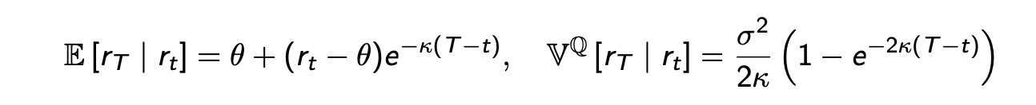

$$E\left[s_{T} when s_{t}\right]=θ_{S}+\left(s_{t}-θ_{S}\right)·e^{-κ_{s}(T-t)}$$
$$V\left[s_{T} when s_{t}\right]=\frac{σ_{S}^{2}}{2κ_{S}}\left(1-e^{-2·κ_{S}\left(T-t\right)}\right)$$

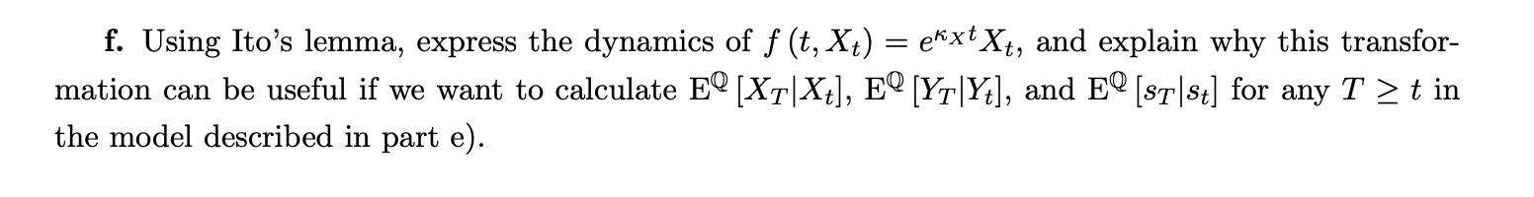
Itos lemma
$$d f\left(t,X\left(t\right)\right)=\left\{\frac{∂f}{∂t}\left(t,x\left(t\right)\right)+a\left(t,X\left(t\right)\right)\frac{∂f}{∂x}\left(t,X\left(t\right)\right)+\frac{1}{2}b{\left(t,X\left(t\right)\right)}^{2}·\frac{∂^{2}f}{∂x^{2}}\left(t,X\left(t\right)\right)\right\}dt+b\left(t,X\left(t\right)\right)·\frac{∂f}{∂x}\left(t,X\left(t\right)\right) dW_{t}$$
$$\frac{∂f}{∂t}=κ·f$$
$$\frac{∂f}{∂X}=\frac{f}{X}$$
$$\frac{∂^{2}f}{∂X^{2}}=0$$
$$a=κ·\left(θ-X\right)$$
$$b=σ$$
$$df=\left(κ·f+κ·\left(θ-X\right)·\frac{f}{X}\right)dt+σ·\frac{f}{X}·dW_{t}$$
$$=\left(κ·e^{κ·t}·X+κ·θ·e^{κ·t}-κ·e^{κ·t}·X\right)dt+σ·e^{κ·t} dW_{t}$$
$$=\left(κ·θ·e^{κ·t}\right)dt+σ·e^{κ·t} dW_{t}$$
This is quite nice because we nolonger have to solve any stochastic integrals thus to get an expression with W_T-t which is just normal then it becomes way easier to calculate the expectation by using lotus
Under is just an expression of the function f
$$f\left(s_{T},T\right)=f\left(S_{t},t\right)+\int_{t}^{T}{\left(κ·θ·e^{κ·s}\right)ds}+W_{T-t}$$

